November 7th 2018

14:00 – 16:00 Welcome reception, registration: Lviv State University of Life Safety

16:30 – 16:40 Opening ceremony of FESE 2018

Session I. Oral presentation (16:40 – 18:40)
Co-chairman: Małgorzata Majder-Łopatka, Starodub Yuriy

16:40 – 17:00 Havrys A., Starodub Y.: Conceptual model of portfolio management project for territories protection against flooding
17:00 – 17:20 Yemelyanenko S., Rudyk Y., Kuzyk A., Yakovchuk R.: Geoinformational system of rescue services
17:20 – 17:40 Tryhuba A., Ratushny R., Bashynsky O., Shcherbachenko O.: Identification of firefighting system configuration of rural settlements
17:40 – 18:00 Lusch V., Loik V., Lazarenko O., Majder-Łopatka M.: Determination of training conditions of firefighters in mobile training complexes
18:00 – 18:20 Gold Sponsor – Władysław Radzik – President of the company Ślusarstwo
18:20 – 18:40 Ivanusa A.: Project of forming «culture and safety» of the airport

Poster session I (16:00 – 19:00)
Co-chairman: Dmytro Voitovych, Andrzej Mizerski

- Binio J., Kieliszek S.: Analysis of the use for Fire Protection Water Supply Systems in public utility buildings and residential buildings
- Fliszkiewicz M., Kreński K.: Numerical analysis on smoke and heat control system and sprinkler system in covered car parks
- Gałaj J., Drzymała T.: Assessment of extinguishing efficiency of hybrid system using water mist and inert gas during class A fires
- Gałaj J., Piątek P.: Analysis of the influence of the spraying angle on the distribution of sprinkling intensity by a selected Turbo water nozzle
- Gancarczyk D., Sobolewski M., Książek P.: Efficiency of sorbents used to restore the grip of the surface of the oily road
- Jakubiec J., Sobolewski M., Król B., Gancarczyk D.: Proportioning accuracy of foam concentrate testing in periodic control of foam fixed extinguishing systems
- Łapicz M., Makowski R., Jedrzejas J.: Increased effectiveness of firefighting during internal fires with the use of positive pressure attack
- Majder Łopatka M.: Effects of interfering gases in electrochemical sensors NH₃ and NO₂
- Matuszkiewicz R.: Statistical analysis of State Fire Service intervention during chemical, radiation and biological hazards
- Piec, R., Cisek M., Ciszewski K.: Evacuation of people to a medium-high public buildings
- Polańczyk A., Ciuka-Witrylak M., Synelnikov O., Loik V.: Analysis of sorption of vehicle liquids with sand that appear after car accidents reproduced in laboratory scale
- Ptak Sz.: The course of electrostatic spark discharge in the context of explosion safety
- Rakowska J.: Best practices for selection and application o firefighting foam
- Rybiński J., Szajewska A.: Determination of fire parameters in a passenger car fire test using thermovision
- Szajewska A.: Classification of a burnt area based on spectral images
- Tuśnio N.: Applications for mobile devices informing about threats
- Walczak A., Naworol I., Pieniak D., Posierbiewicz K., Wąsik W.: Experimental studies of changes in mechanical properties of polymer composites under impact of thermal load determined based on compression testing
19:30 – Official dinner Restaurant: Pysanka
November 8th 2018

Session II. Oral presentation (9:30 – 11:40)
Co-chairman: Andrzej Polańczyk, Borys Mykhalichko

9:00 – 9:20 Popovych V., Stepova K., Prydatko O.: Environmental hazard of Novoyavorivsk municipal landfill
9:20 – 9:40 Vaselivskyy R., Starodub Y., Vasylenko O.: Simulation of process with a heat transfer in multilayer structure X and correcting structure
9:40 – 10:00 Yakovchuk R., Semerak M., Pozdeev S., Nekora O., Sviatkevych O.: Mathematical modeling of a thermal fire effect on tanks with oil products
10:00 – 10:20 Boroń S., Wdowiak T.: Numerical representation of extinguishing gas discharge process
10:20 – 10:40 Woliński M.: Industry 4.0 and explosion prevention
10:40 – 11:00 Krasuski A., Pecio M.: Application of an Integrated Risk Assessment Software to Quantify the Life Safety Risk in Building during a Fire
11:00 – 11:20 Bronze Sponsor – Kamil Marjanek – President of the company Foamax
11:20 – 11:40 Mizerski A.: Wetting properties of aqueous short-chain alcohols’ solutions

Poster session II (9:00 – 12:00)
Co-chairman: Andriy Havrys, Marek Woliński

- Adamkiewicz Ł., Gayer A.,, Mucha D., Badyda A.: Air quality health indices – review
- Dmochowska A.: Hazards associated with municipal waste storage. Vol. II
- Dmochowska A.: Hazards associated with municipal waste storage. Vol. I
- Janoszka K., Klyta J., Laks Ł., Słaby K.: The use of polycyclic aromatic hydrocarbons molecular diagnostic ratios as a source identification tool – case study
- Kamocka-Bronisz R.: Tensile strength analysis of aramid fabric of firefighter’s clothing after accelerated aging and abrasion
- Kmiecik K.: Finite element analysis of heat flow within timber members exposed to fire
- Krasuski A., Kuziora Ł.: Comparison of Risk Categorization Methods in a Multisimulation Framework
- Krauze A.: The application of CFD software in the explosive hazardous area classification
- Kuskowska K., Rogula-Kozłowska W.: Seasonal variation in health exposure to PM-bound Polycyclic Aromatic Hydrocarbons in selected sport facility
- Marciniak A.: Analysis of the influence of the heating process on the charring depth of wooden elements
- Mierzwiński D., Łach M., Korniejenko K., Mikuła J.: Geopolymer foam as a Passive Fire Protection
- Mierzwiński D., Łach M., Korniejenko K., Stanek A., Mikuła J.: The behavior of Alkali Activated Materials based on calcium clay at elevated temperatures
- Parzych S., Dziurka R., Gucwa M.: Determining the causes of failure of the distillation column for the esterification of n-butanol with acetic acid
- Parzych S., Dziurka R., Gucwa M.: Influence of post weld heat treatment for weld joint P355GH
- Rakowska J., Kuskowska K., Rogula-Kozłowska W.: Inhalation exposure to particulate matter in a work environment of firefighters
- Salamonowicz Z.: Numerical simulation of dispersion of ammonia in industry space using the ANSYS
- Wąsik W., Walczak A.: The impact of fog nozzle type on the distribution of mass spray density
11:40 – 12:30 – Cafe break

Session III. Oral presentation (12:30 – 14:30)
Co-chairman: Vasyl Kovalyshyn, Adam Krasuski

12:30 – 12:50 Platinum Sponsor – Ryszard Grosset – DJ Chem Chemicals Poland S.A.
12:50 – 13:10 Makovicka Osvaldova L.: Burning rate of selected central European hardwood tree species
13:10 – 13:30 Kmiecik K.: The influence of the fire source location on the load-bearing capacity of timber beam exposed to fire
13:30 – 13:50 Powęzka A., Banaś M., Ogrodnik P.: Checking the compatibility of embedded concrete for the production of prefabricated freight scales with the parameters declared by the supplier
13:50 – 14:10 Polańczyk A.: The usefulness of Gram staining method for analysis of the effectiveness of decontamination of firefighter’s protective outfit
14:10 – 14:30 Gayer A., Mucha D., Adamkiewicz Ł., Badyda A.: Children exposure to PM2.5 in kindergarten classrooms equipped with air purifiers – a pilot study

Poster session III (12:00 – 14:45)
Co-chairman: Agata Walczak, Volodymyr Tovarianskyi

- Boroń S., Kubica P.: Modeling of the process of the extinguishing gas concentration changes in the protected compartment
- Jarosz W., Kowalczyk P., Marciniak A.: The determination of basic firefighters rescue operations of key practical importance
- Kozielska B.: Health hazards from polycyclic aromatic hydrocarbons bound to submicrometer particles in Gliwice (Poland)
- Kreński K., Fliszkiewicz M.: AAmks: the platform for assessing fire safety of humans in buildings
- Król B., Konecki M., Klakus M.: The use of a cone calorimeter for the preliminary determination of the extinguishing efficiency of bulk materials
- Kukfisz B.: Analysis of minimum ignition temperature of pellet dust layer and cloud due to adding BC and ABC ire extinguishing powder
- Kukfisz B.: Flammability parameters of sprayed and foam aerosols selected for studies
- Półka M.: Analysis of susceptibility of inflammable tobacco products dust to ignition from a heated surface
- Półka M.: Analysis of susceptibility of peat on its spontanous heating and self-ignition properties
- Rogula-Kopiec P., Nocoń K. Pastuszka J.S.: Metals and their water-soluble fractions in selected beauty salons
- Salamonowicz Z., Matuszkiewicz R., Ciuka Witrylak M., Kosiorek M., Biedugnis S.: The effectiveness of selected decontamination techniques in the process of decontamination of chemical protection suits used by chemical rescue units in Fire Service
- Sienkiewicz-Jarosz H., Konopko M., Jarosz W., Bienkowski P.: Work-related factors and depressive symptoms in firefighters – preliminary data
- Szuszkiewicz M.M., Łukasik A., Magiera T., Szuszkiewicz M.: Technogenic magnetic particles of topsoil from different sources of emission – A case study from Upper Silesian conurbation, Poland
- Umbetkulov Y., Yeleukulov Y., Atalykova A., Smailova G., Iskakova G., Zhauyt A., Gulama-Garip Alisher Ibrayev: Dynamic force analysis of a six-link planar mechanism
- Wdowiak T., Kubica P.: The use of multisimulation in determining fire hazards in buildings covered by expertise
- Zubek Ł., Sobolewski M.: The effect of selected inhibitors on the characteristics of wood dust explosion

14:30 – 15:30 – Lunch

15:50 – 16:00 – Closing ceremony of FESE 2018

Sponsors

Honorary Patronage

Prof. Miroslav Koval
Rector of Lviv State University
of Life Safety
Ukraine

Brig Gen. Paweł Kępka
Associate Prof. Rector-Commandant of The Main School of Fire Service
Poland
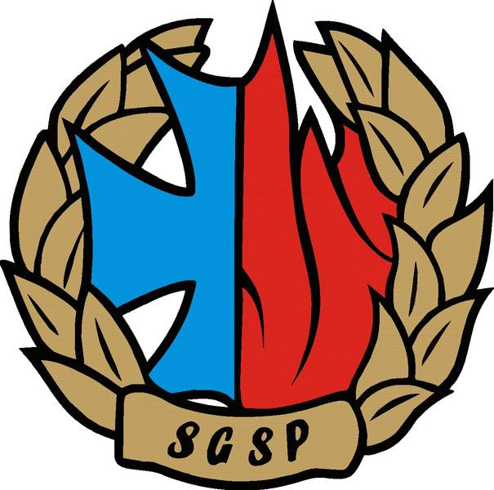

Fire and Environmental Safety Engineering 2018
(FESE 2018)
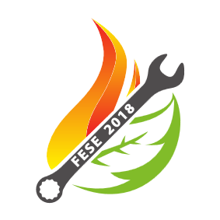

Lviv, 7-8 November 2018

